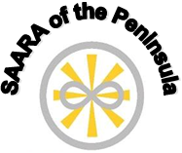

Substance Abuse and Addiction Recovery Alliance of the Peninsula

WORKSHOP DAY
March 30, 2019
9:00 AM – 5:00 PM

Motivational Interviewing for Peer Providers
Six (6) CEUs

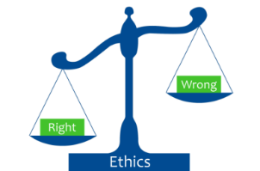
Ethics Governing the Peer Profession
Six (6) CEUs

(Limited Seating)

Location: Hampton-Newport News CSB, 300 Medical Drive, Hampton, VA 23666

Registration Fee: $50.00 (Includes continental breakfast, snacks and lunch)

Registration Deadline: The registration form, signed authorization to release form and payment must be received by March 22, 2019. On-site registration will be limited and be advised that your Certificate of Completion may be mailed to you.

Payment: We accept cash, organizational checks and money orders which should be made payable to SAARA of Virginia with SAARA of the Peninsula Workshop Day in the memo section. Personal checks will not be accepted.

Please mail to: SAARA of the Peninsula, c/o Alethea Lambert, 300 Medical Drive, Hampton, VA 23666.

Please contact Alethea Lambert, CPRS at 757-696-1661 or Frederika Jones at 757-810-5528 for more information.

